You have recently joined a web development company, Hot Beans Web as a junior web developer. You have been asked as part of your induction and training to create a new section for the company’s web site which promotes the company to prospective employees, as they need to recruit more web developers. The company wants you to include the following things:

• A profile of the company itself

• profiles of existing trainee web developers

• job specifications and required qualifications

• an on-line application forms

• links to web development courses

The target audience for the site is people who have completed training courses or qualifications related to web development and are now looking for a job as a web developer.

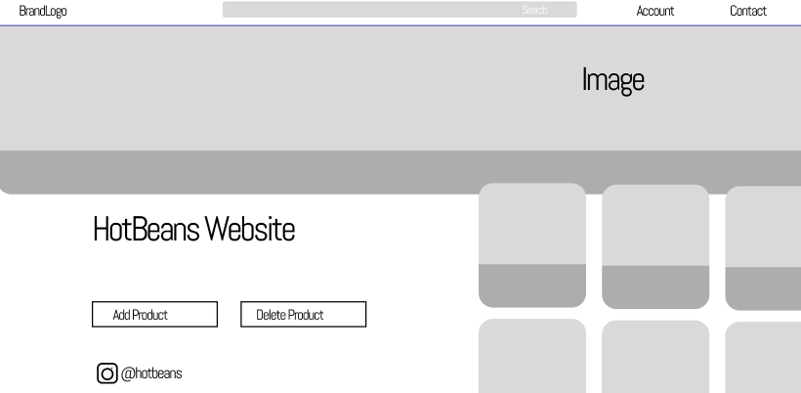

The main page of the website is located here. This page will provide some quick facts regarding the hot beans website. I'll also provide a photograph associated with the website.

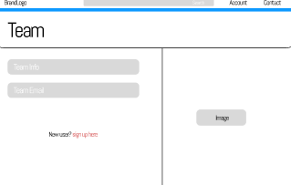

The website's team page is located here. Information about the employees of the Hot Bean Company and their roles within the organisation will be available on this website.

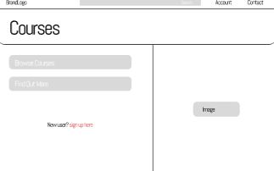

This is the courses page of the website. There will be different courses link with image and YouTube links.

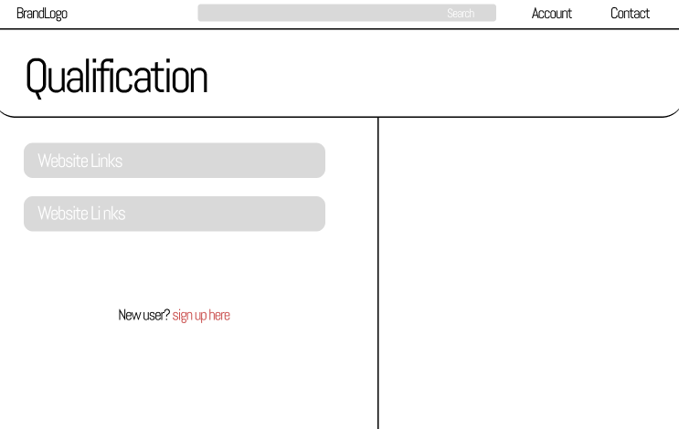

This is the qualifications page of the website. This would talk about the achievements the company has acheived

